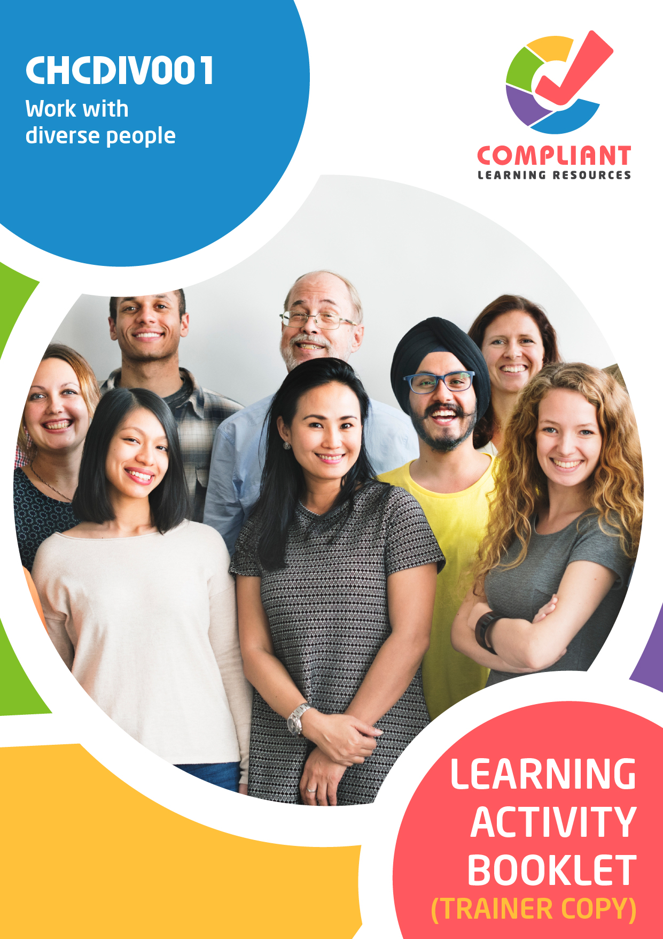

**Copyright**

This document was developed by Compliant Learning Resources.

© 2023 Compliant Learning Resources.

All rights reserved.

No part of this publication may be reproduced, stored in a retrieval system, or transmitted in any form or by any means, electronic, mechanical, photocopying, recording, or otherwise without the prior written permission of Compliant Learning Resources.

**Version Control & Document History**

|  |  |  |
| --- | --- | --- |
| **Date** | **Summary of Modifications** | **Version** |
| 21 May 2021 | Version 1.0 released for publishing | 1.0 |
| 10 August 2022 | Version 2.0 released for publishing   * Updated based on changes made to the Learner Guide | 2.0 |
| 19 May 2023 | Version 2.1 released for publishing   * Fixed minor wording issues | 2.1 |
| 25 May 2023 | Version 2.2 endorsed for use   * Revised Activity 3.2 | 2.2 |

# Table of Contents

Overview 4

Trainer Instructions 5

Learner Instructions 6

Learner Information 6

Trainer Information 6

Resources Required 7

Work Health and Safety 7

Reasonable Adjustment 8

Contextualisation 9

Formative Activities 10

I. Reflect on Own Perspectives 10

Activity 1.1 10

Activity 1.2 11

II. Appreciate Diversity and Inclusiveness, and Their Benefits 12

Activity 2.1 12

Activity 2.2 13

III. Communicate with People from Diverse Backgrounds and Situations 14

Activity 3.1 14

Activity 3.2 15

IV. Promote Understanding Across Diverse Groups 17

Activity 4.1 17

Activity 4.2 18

Activity 4.3 19

# Overview

**CHCDIV001 - Work with diverse people (Release 1)**

This unit describes the skills and knowledge required to work respectfully with people from diverse social and cultural groups and situations, including Aboriginal and/or Torres Strait Islander people.

This unit applies to all workers.

*The skills in this unit must be applied in accordance with Commonwealth and State/Territory legislation, Australian/New Zealand standards and industry codes of practice.*

**A complete copy of the above unit of competency can be downloaded from the TGA website:**

<https://training.gov.au/Training/Details/CHCDIV001>

# Trainer Instructions

This Learning Activity Booklet contains formative activities that learners will complete in the classroom or a similar environment.

These formative activities include knowledge questions to test learners’ underpinning generic knowledge and practical activities to test their skills relevant to the unit/s of competency.

These formative assessments are used by trainers to complement both the learning and training processes, and to evaluate how learners are progressing throughout these processes.

**IMPORTANT:**

**The completion of the formative assessments and learning activities included in this workbook DOES NOT lead to a Qualification or a Statement of Attainment (SOA).**

Reasonable adjustment applies here, and while the majority of learners will complete this assessment as a written assessment, verbal assessment may be an option for those who need it. The assessor must use the marking guide as the principal marking tool unless a reasonable adjustment is demonstrated.

The Learning Activity Booklet (Trainer Copy) provides model answers to all the questions, setting out which key responses must be included as well as indicating where flexibility is acceptable.

The number of responses required is specified in each assessment task to avoid ambiguity. In these cases, the model answer will provide a list of possible answers. For instance, if a question requires the learner to list three examples, then their response must include three of the items listed in the model answer.

# Learner Instructions

This Learning Activity Booklet contains formative activities that learners will complete in the classroom or a similar environment.

These formative activities include knowledge questions to test your underpinning generic knowledge and practical activities to test your skills relevant to the unit/s of competency.

These formative assessments are used by your trainer to complement both the learning and training processes, and to evaluate how you are progressing throughout these processes.

You may reference your Learner Guide and other learning materials to complete the activities included in this workbook.

**IMPORTANT:**

**The completion of the formative assessments and learning activities included in this workbook DOES NOT lead to a Qualification or a Statement of Attainment (SOA).**

## Learner Information

|  |  |
| --- | --- |
| Learner name |  |
| Phone |  |
| Email |  |

## Trainer Information

|  |  |
| --- | --- |
| Trainer name |  |
| RTO name |  |
| RTO phone |  |
| RTO email |  |

# Resources Required

Resources needed to complete activities included in this workbook include:

* Computer with Internet, email access, and a working web browser
* Installed software: MS Word, Adobe Acrobat Reader
* Learner guide

# Work Health and Safety

Both the trainers and learners have duty of care in ensuring that the learning environment is free from hazards that may pose risks to their health and safety.

According to WHS legislation, trainers and learners must take reasonable care while undertaking the activities included in this workbook in the learning environment.

# Reasonable Adjustment

‘Reasonable adjustment’ in VET is the term applied to modifying the learning environment or making changes to the training delivered to assist a learner with a disability. A reasonable adjustment can be as simple as changing classrooms to be closer to amenities or installing a particular type of software on a computer for a person with vision impairment.

**Why make a reasonable adjustment?**

We make reasonable adjustments in VET to make sure that learners with disabilities have:

* The same learning opportunities as learners without disabilities, and
* The same opportunity to perform and complete assessments as those without disabilities.

**Reasonable adjustment applied to participation in teaching, learning, and assessment activities can include:**

* Customising resources and assessment activities within the training package or accredited course
* Modifying the presentation medium
* Learner support
* Use of assistive/adaptive technologies
* Making information accessible both before enrolment and during the course
* Monitoring the adjustments to ensure learner needs continue to be met

**Assistive/Adaptive Technologies**

Assistive/adaptive technology means ‘software or hardware that has been specifically designed to assist people with disabilities in carrying out daily activities’ (World Wide Web Consortium - W3C). It includes screen readers, magnifiers, voice recognition software, alternative keyboards, devices for grasping, visual alert systems, and digital note-takers.

*(Adapted Reasonable Adjustment in teaching, learning and assessment for learners with a disability - November 2010 - Prepared by - Queensland VET Development Centre)*

**IMPORTANT:**

**Reasonable adjustment made for collecting learner assessment evidence must not impact the standard expected by the workplace, as expressed by the relevant unit/s of competency. For example, if the assessment were gathering evidence of the learner’s competency in writing, allowing the learner to complete the assessment verbally would not be a valid assessment method. The method of assessment used by any reasonable adjustment must still meet the competency requirements.**

# Contextualisation

Contextualisation is the process of modifying assessment tools to make learning more meaningful for your students and their employers.

Compliant Learning Resources highly recommends that your RTO contextualise the assessment tools before using them.

You must contextualise the assessment tools to suit:

* Your student’s needs
* Your RTO’s training and assessment processes
* The work and industry context in which you operate

**Contextualising for your state/territory**

The contents of this assessment tool are not written for a specific state/territory unless stated otherwise. Where the assessment tool refers to legislation and other industry requirements, which may vary across states/territories, model answers are based on one state/territory.

Should your RTO intend to use this assessment tool for learners from your state/territory, Compliant Learning Resources recommends you to:

* Access and review the legislation and industry requirements applicable in your state/territory.
* Update assessments and benchmark answers to reflect the legislation and industry requirements applicable in your state/territory.

When you are contextualising assessment tools, you must ensure that you retain the integrity of the assessment and the outcomes of the unit of competency.

**A comprehensive guide to contextualising your assessment tools for your RTO can be accessed through this link:**

<https://compliantlearningresources.com.au/blog/simple-guide-to-contextualising-rto-training-resources-and-assessment-tools/>

# Formative Activities

## I. Reflect on Own Perspectives

### Activity 1.1

|  |  |
| --- | --- |
| **True or False**  Review the statements below about biases, perspectives, inclusivity, awareness and human rights. Indicate whether each statement is true or false.  Tick the box that corresponds to your answer. | |
|  | |
| *Mapping: CHCDIV001 PC 1.1 (p), PC1.2 (p), PC1.3 (p), KE5.2.1 (p)*  *Learner guide reference:*   * *CHCDIV001 Learner Guide, Chapter 1, Subchapter 1.1* * *CHCDIV001 Learner Guide, Chapter 1, Subchapter 1.2* * *CHCDIV001 Learner Guide, Chapter 1, Subchapter 1.3, Introduction* * *CHCDIV001 Learner Guide, Chapter 1, Subchapter 1.3, Section 1.3.2* | |
| TRUE  FALSE | 1. Cultural bias is your predisposition to favour one set of values, behaviour, and knowledge over another. |
| TRUE  FALSE | 1. Cultural perspective is your view of or the particular attitude you have towards a community, society or a group of people. |
| TRUE  FALSE | 1. Social bias entails understanding how a person’s social traits may inform their values, behaviour, beliefs and basic assumptions. |
| TRUE  FALSE | 1. Human rights are based on the obligation to yourself and others as human beings to uphold liberty, dignity, equality, fairness, respect, and independence. |
| TRUE  FALSE | 1. To work inclusively means to work in a way that upholds and protects the rights and dignity of all persons. |

### Activity 1.2

|  |
| --- |
| Identify three principles to follow when improving yourself. |
|  |
| *Mapping: CHCDIV001 PC1.4 (p)*  *Learner guide reference: CHCDIV001 Learner Guide, Chapter 1, Subchapter 1.4*  **Marking guide**  The learner must list down three principles to follow when improving themselves.  For a satisfactory performance, although the wording may slightly vary, their response must include three of the following:   * Have a realistic goal. * Tap into existing resources. * Progress is key. * Be yourself. * Have discipline. |
|  |
|  |
|  |

## II. Appreciate Diversity and Inclusiveness, and Their Benefits

### Activity 2.1

|  |
| --- |
| **Fill in the blanks**  The following are statements on inclusiveness and diversity in the workplace and the practices that promote these values. Review each and complete the statement by filling in the missing words/phrases. |
|  |
| *Mapping: CHCDIV001 PC2.1 (p), PC2.3 (p), KE 8.1 (p), KE 8.3 (p)*  *Learner guide reference:*   * *CHCDIV001 Learner Guide, Chapter 2, Subchapter 2.1, Introduction* * *CHCDIV001 Learner Guide, Chapter 2, Subchapter 2.1, Section 2.1.2* * *CHCDIV001 Learner Guide, Chapter 2, Subchapter 2.1, Section 2.1.3* * *CHCDIV001 Learner Guide, Chapter 2, Subchapter 2.3, Section 2.3.1* * *CHCDIV001 Learner Guide, Chapter 2, Subchapter 2.3, Section 2.3.2* |
| 1. Cultural diversity refers to differences between aspects or characteristics of cultures.       Inclusiveness is allowing equal opportunities and participation to people despite differences in culture. |
| 1. Values are the principles, beliefs, and practices that are considered intrinsically desirable by a cultural group.       Cultural norms are typically seen as behaviour patterns that a cultural group demonstrates. |
| 1. Western       systems refer to the west’s set of principles and procedures for performing actions and carrying about daily life. Western       structures refer to the west’s set of social institutions and patterns of relationships, such as in communities, families and governments. |
| 1. Risk factors are entities or situations that can cause negative effects. The opposite happens with       protective factors, where positive effects come up. |
| 1. Discrimination is the unjust and prejudicial treatment of a group of people.       Exclusion means being removed from the bigger group. |

### Activity 2.2

|  |  |
| --- | --- |
| List two advantages and two disadvantages of developing professional relationships that are based on acceptance of cultural diversity. | |
|  | |
| *Mapping: CHCDIV001 PC2.2 (p)*  *Learner guide reference: CHCDIV001 Learner Guide, Chapter 2, Subchapter 2.2*  **Marking guide**  The learner must list two advantages and two disadvantages of developing professional relationships that are based on acceptance of cultural diversity.  For a satisfactory performance, their response must be positive and negative aspects to forming close, inclusive relationships in the workplace by respecting and appreciating diversity and inclusion  Sample answers are provided below (only two are required):   |  |  | | --- | --- | | Advantages | Disadvantages | | Working with others is enjoyable | People with power or strong personalities can dominate the relationship dynamic | | It is easier to generate new ideas | It can be difficult to get people together, and managing ideas can be cumbersome | | Everyone can share in decision-making | It can take a long time to make decisions | | Everyone can feel pride in being part of a group | Arguments could occur more frequently if all members had strong opinions | | Members will be more committed decisions they make. | Less confident or quiet people may have difficulty contributing to discussions | | Members will be able to support each other. | Some members may not be as supportive as others | | |
| **Advantages** | **Disadvantages** |
|  |  |
|  |  |

## III. Communicate with People from Diverse Backgrounds and Situations

### Activity 3.1

|  |
| --- |
| **Matching Type**  Listed below are concepts related to the use of communication.   1. Language barrier 2. Written language 3. Language interpretation 4. Diversity in communication 5. Constructive communication   Match each to their description below by writing the letter that corresponds to your answer in the space provided. |
|  |
| *Mapping: CHCDIV001 PC3.1 (p), PC3.2 (p), PC3.3 (p), PC3.4 (p), KE9.1 (p)*  *Learner guide reference:*   * *CHCDIV001 Learner Guide, Chapter 3, Subchapter 3.1* * *CHCDIV001 Learner Guide, Chapter 3, Subchapter 3.2, Section 3.2.1* * *CHCDIV001 Learner Guide, Chapter 3, Subchapter 3.2, Section 3.2.2* * *CHCDIV001 Learner Guide, Chapter 3, Subchapter 3.3* * *CHCDIV001 Learner Guide, Chapter 3, Subchapter 3.4* |

|  |  |
| --- | --- |
| Description | |
| e | 1. It is a style of communication used when addressing issues or resolving conflicts. |
| d | 1. It refers to the different ways of communicating with the persons in your workplace. |
| a | 1. It occurs when two people cannot communicate due to differences in their language. |
| c | 1. It is the process through which one expression or source of information provided through a certain language is expressed in a different language. |
| b | 1. It is part of non-verbal communication. It can refer to both the characters of the alphabet and the symbols and pictures people draw to convey meaning. |

### Activity 3.2

|  |
| --- |
| **SCENARIO**  Jane is a young woman who came to the community centre to ask for assistance in interviewing an Aboriginal child as part of her work. As an Australian woman who speaks English, she felt that it was necessary to get proper help before approaching a family. Jane was scheduled to meet John, a fourteen-year-old Aboriginal boy whose father is a *mayutju* or esteemed member of his Aboriginal community. John was described as a shy boy who preferred keeping to himself rather than playing with children of his age. He spent much of his time listening to music wherever he heard it and only spoke when talked to.  On the day of the interview, Jane went to the interview alone. Jane found it difficult to communicate with John. When asked questions, he would either provide no response or would answer inappropriately with a “yes” or a “no.” When he did give detailed responses, he had difficulties expressing his ideas in English and used words that were unfamiliar to Jane.  Realising the communication challenges with John, she changed her approach. First, she tried to engage John in conversations about his interests. She also gave him enough time to reflect on his answers when she asked him questions. She avoided interrupting John whenever he shared his thoughts. John began to express himself more freely. |
| Before her second meeting with John, Jane went to the community centre and asked for assistance. After hearing of Jane’s experiences, an interpreter was assigned to guide and assist Jane with her task by giving her a set of instructions on what to do. She also prepared visual aids to accompany her questions.  During the second interview, John understood the questions better. He was more comfortable and participative. |

|  |
| --- |
| List two effective communication approaches Jane used. |
|  |
| *Mapping: CHCDIV001 PC3.2 (p)*  *Learner guide reference: CHCDIV001 Learner Guide, Chapter 3, Subchapter 3.2, Section 3.2.2*  **Marking guide**  The learner must list two effective communication strategies Jane used.  Responses may vary. For a satisfactory performance, their response must be:   * Verbal or non-verbal techniques used to convey information, ideas, or messages in a clear, concise, and impactful manner * Consistent with the scenario   Model answers are provided below: |
| Use of visual aids |
| Use of interpreter |

## IV. Promote Understanding Across Diverse Groups

### Activity 4.1

|  |  |
| --- | --- |
| **True or False**  Review the statements below about resolving cross-cultural conflicts. Indicate whether each statement is true or false.  Tick the box that corresponds to your answer. | |
|  | |
| *Mapping: CHCDIV001 PC4.1 (p), PC4.2 (p), PC4.3 (p), PC4.4 (p)*  *Learner guide reference:*   * *CHCDIV001 Learner Guide, Chapter 4, Subchapter 4.1* * *CHCDIV001 Learner Guide, Chapter 4, Subchapter 4.2* * *CHCDIV001 Learner Guide, Chapter 4, Subchapter 4.3* * *CHCDIV001 Learner Guide, Chapter 4, Subchapter 4.4* | |
| TRUE  FALSE | 1. Making a hasty generalisation of a society or community may cause misunderstandings in the workplace. |
| TRUE  FALSE | 1. Bias and discrimination can be tolerated on any level within a workplace. |
| TRUE  FALSE | 1. When resolving conflicts involving differences in culture, how you resolve the issue is just as important as what your resolution is. |
| TRUE  FALSE | 1. One sensitive resolution to a conflict is identifying a person’s cultural traits and characteristics as the source of the problem. |
| TRUE  FALSE | 1. You must seek assistance when dealing with a person from a cultural or social background you are not familiar with. |

### Activity 4.2

|  |  |  |  |  |  |  |
| --- | --- | --- | --- | --- | --- | --- |
| **Matching Type**  Identify the form of discrimination being described in each statement below.   |  | | --- | | **Form of Discrimination** | | Racism | | Prejudice | | Ageism | | Stereotypes | | |
|  | |
| *Mapping: CHCDIV001 PC4.1 (p)*  *Learner guide reference: CHCDIV001 Learning Guide, Chapter 4, Subchapter 4.1* | |
| Definitions | |
| Ageism | 1. A situation where people nearing or past the retiring age are treated very differently in the workplace compared to the ideal working ages. |
| Stereotypes | 1. Majority-held beliefs about social groups that can either be positive or negative. |
| Prejudice | 1. Usually refers to a negative pre-judgment. |
| Racism | 1. A situation where a person is treated less favourably than another, due to their race, ethnicity, national origins, nationality, or colour. |

### Activity 4.3

|  |
| --- |
| Explain the impact of cultural diversity on misunderstandings and provide two actions when mediating between two arguing parties. |
|  |
| *Mapping: CHCDIV001 PC4.2 (p)*  *Learner guide reference: CHCDIV001 Learner Guide, Chapter 4, Subchapter 4.2*  **Marking guide**  The learner must explain the impact of cultural diversity on misunderstandings and provide two actions when mediating between two arguing parties.  For a satisfactory performance, although the wording may slightly vary, their response must be consistent with the benchmark answer below. |
| Explain the impact of cultural diversity on misunderstandings,    Considering the impact of cultural diversity takes into account differences in culture when difficulties or misunderstandings occur. Your cultural perspectives and biases may cause conflict. Cultures have different beliefs, practices and ideals. There may be actions that are considered insulting to others. The same actions may convey different meanings to different cultures. |
| Provide two ways to make an effort to resolve differences sensitively.       The candidate’s response may vary. It may include two of the following:   * Get both parties to relax. * Have ground rules in place. * Have each person speak in turns. * Work on a compromise. * Explore issues together.   Other responses are acceptable, provided that they are ways to mediate between two arguing parties. These refer to actions assisting both parties in understanding why they are experiencing difficulties or misunderstandings and in coming to an agreement or resolution. |

End of Document